**Rights Respecting Schools and Nurture**

Our work on these important areas continued last term with our weekly assemblies focusing on thinking about our rights and how we use them.

We marked the International Day of Peace with the children designing a very different kind of day which included activities that helped us to feel at and enjoy peace.

The children enjoyed yoga, mindfulness colouring, a forest walk and a story about making peace amongst friends. They also reflected afterwards that choosing a game of football was not perhaps the most effective way of finding peace and harmony with one another after all!

**Environment Project**

The children have closed their projects for the winter and will resume these in the Spring term when planting of the bog-area and growing areas will commence. The Equippers have chosen items they wish to buy and have discussed these with Mr Long and are soon to present their ideas to the Parent Council.



**Carradale Newsletter**

**November 2023**

**Diary Dates**

|  |  |
| --- | --- |
| 16/11 | Into Film Cinema Visit |
| 17/11 | Parents’ Open Afternoon and Children in Need |
| 22/11 | Parent Conferences |
| 24/11 | UHI Stem Programme week 4 |
| 27/11 | INSET – children not in school |
| 28/11 | P6/7 Virtual Games Competition Week |
| 1/12 | UHI Stem Programme week 5 |
| 2/12 | Parent Council Christmas Fayre |
| 8/12 | UHI Stem Programme week 6 |
| 13/12 | Christmas Lunch and Christmas Jumper Day |
| 19/12 | Christmas Party |
| 20/12 | Christmas Show |
| 21/12 | End of term |

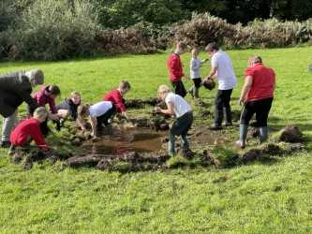

**Dear Parents /Carers,**

Welcome to our Term Two Newsletter.

We have enjoyed a very busy time since we started back at school in August.

We said our goodbyes to Mrs Lunn and wished her a very happy retirement. We hope she’s enjoying lots of fun and adventures.

And we’re delighted to welcome Miss McLaren who will be joining us during November. Miss McLaren will teach P1-3 and is very excited about her new school!

**Maths Week Scotland**

In September, Maths Week Scotland offered us some great fun, this year. As well as lots of maths-themed activities throughout the week, the children were also able to participate in two super online classes.

Our first session was a very lively Maths Through Ceilidh when the children learned all about keeping and counting the beat for dancing.

Our second session combined learning about our healthy hearts and measuring time. Multiple Heartbeats made sure heart beats were felt and counted showing us how to recognise those healthy sounds.

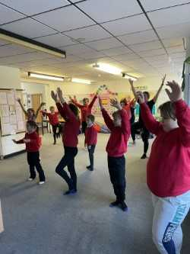

**Pupil Council**

As part of our work on Rights Respecting Schools, the children have been considering more ways that their voices can be heard in school.

One of their suggestions was to create a Pupil Council. We worked together to plan how the council should work and created the following model.

We have a chair who is in the role for this academic year. All children have the opportunity to be on the council with the membership changing every 8 weeks. Members are selected via lottery.

The first focus for the first Pupil Council was to consider a new reward system for personal achievements. The group looked at a range of models and asked the class to vote for their preference.

The new system will be launched soon!

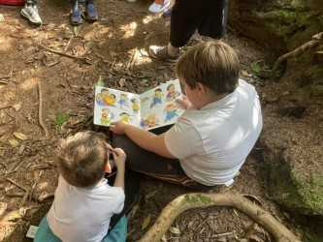

**School Sports**

One of our PE focus areas last term was basketball and as well as learning skills in PE lessons we were lucky to have some specialist coaching from Mrs Ramsay from Active Schools. Children showed great skill and attention to detail. Mrs Ramsay was very impressed with our budding talent!

The term also saw us beginning our Virtual Games practice as November sees the opening of the Virtual Games competition for 2023-2024.

